K-MAP SIMPLIFICATION — QUESTION 6.8
Solved Walkthrough + Complete K-Map Grouping-Strategy Study Guide
4-Variable Boolean Simplification · 10 Marks

This document has two parts: Part A works through Question 6.8 step by step with a labelled diagram for every group; Part B is a general-purpose reference on K-map grouping strategy for revision.

PART A — Solved Solution to Question 6.8

A.1 — Problem Statement
Simplify the following Boolean expression using a 4-variable K-map:
F(A, B, C, D) = Σm(0, 3, 5, 7, 8, 10, 11, 12, 13, 14, 15)
Draw the K-map grid, clearly show the groupings (loops), and write the final simplified Sum-of-Products (SOP) expression.

A.2 — Plot the K-Map
Rows represent AB and columns represent CD, both ordered in Gray code (00, 01, 11, 10) so that any two side-by-side cells — including the wrap from the last column/row back to the first — differ in only one bit. F is 1 for the eleven listed minterms and 0 for the five that are missing from the list: m = 1, 2, 4, 6, 9.
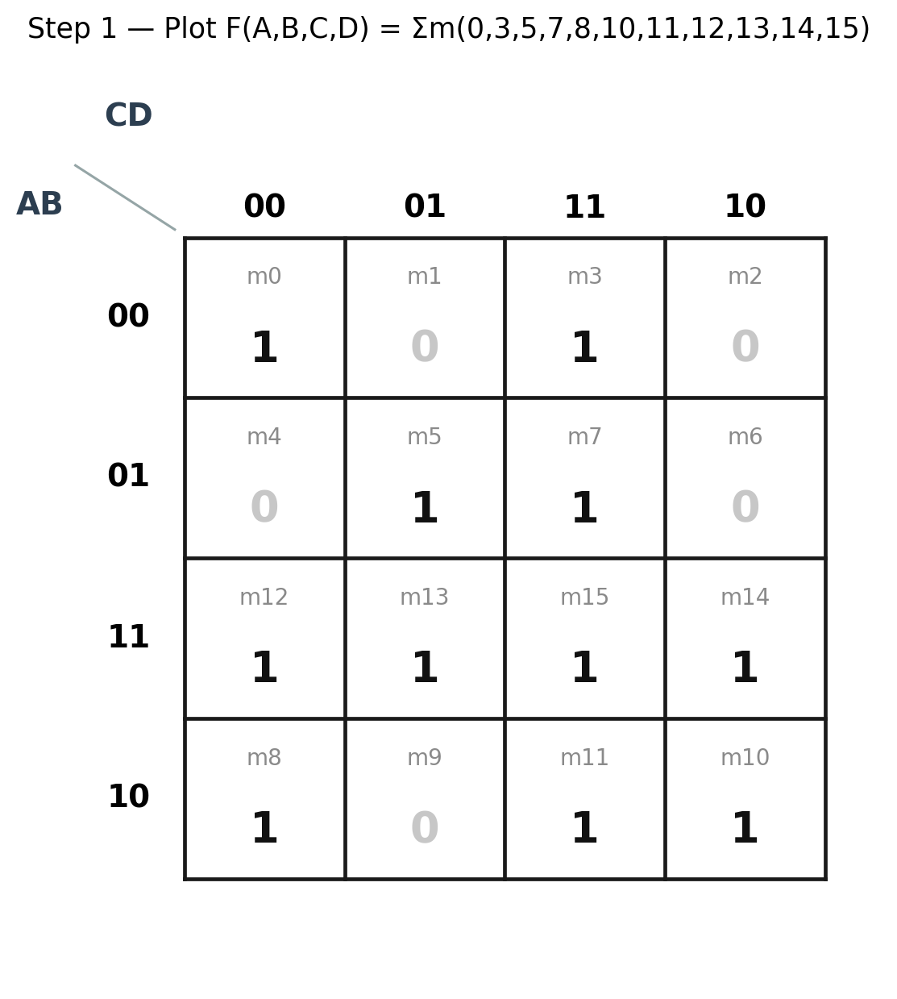

A.3 — Group ① : A · D′ (cells 8, 10, 12, 14)
Rows AB = 11 and AB = 10 both have A = 1. Columns CD = 00 and CD = 10 both have D = 0. That 2×2 region — split across the left and right edges — becomes a single group of 4 once the left-right wraparound is used. A stays fixed at 1 and D stays fixed at 0 across all four cells, while B and C both vary and drop out of the term.
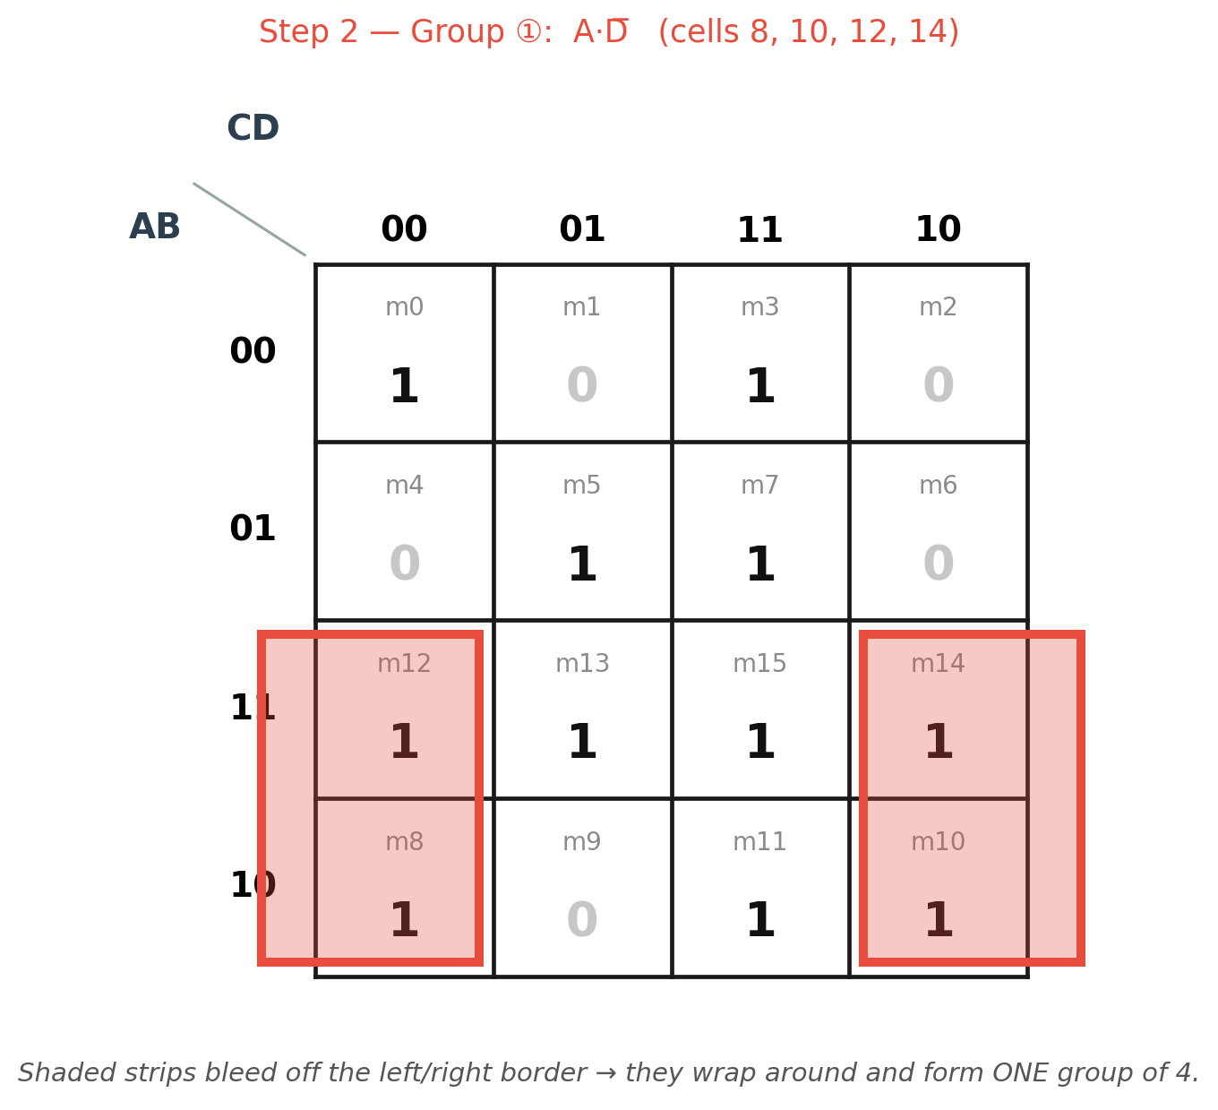

A.4 — Group ② : B · D (cells 5, 7, 13, 15)
Rows AB = 01 and AB = 11 both have B = 1. Columns CD = 01 and CD = 11 both have D = 1. This 2×2 block sits entirely inside the map, so no wraparound is needed. B and D stay fixed; A and C vary and drop out.
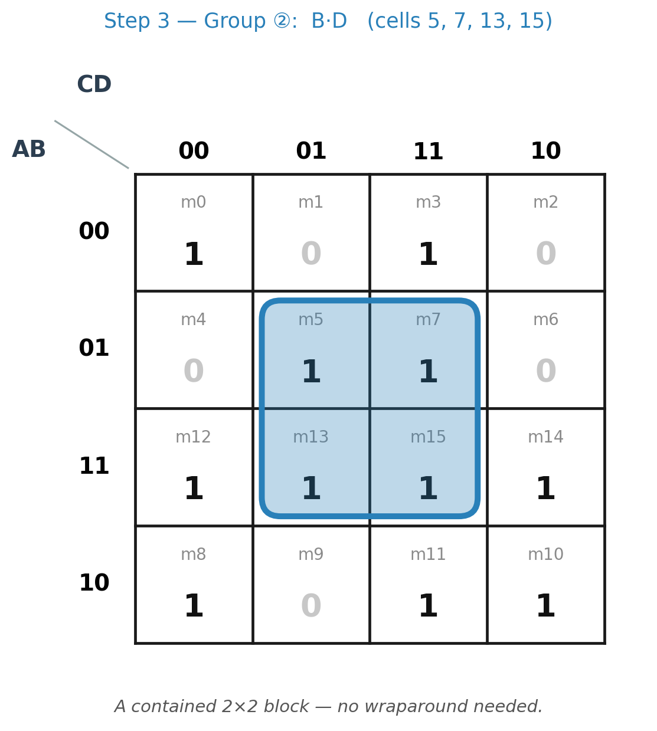

A.5 — Group ③ : C · D (cells 3, 7, 11, 15)
The entire CD = 11 column is 1 in all four rows, so it forms a group of 4 on its own. C and D stay fixed at 1; A and B vary freely down the column and drop out.
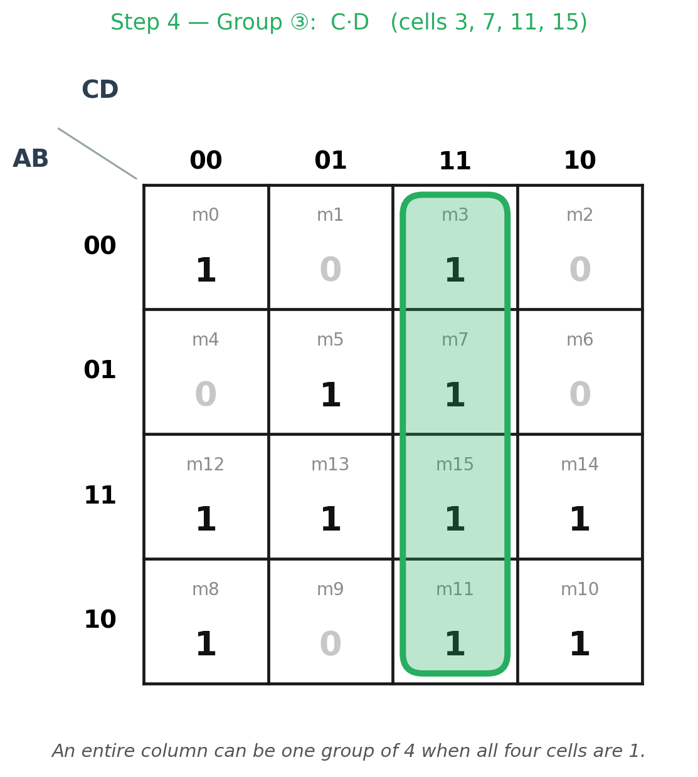

A.6 — Group ④ : B′ · C′ · D′ (cells 0, 8)
Cell 0's only 1-valued neighbour is cell 8 — its other neighbours, cells 1, 2 and 4, are all 0 — so the largest possible group containing cell 0 is this pair, formed using the top-bottom wraparound. B, C and D all stay fixed at 0, and only A varies, so only A drops out, leaving three literals instead of two.
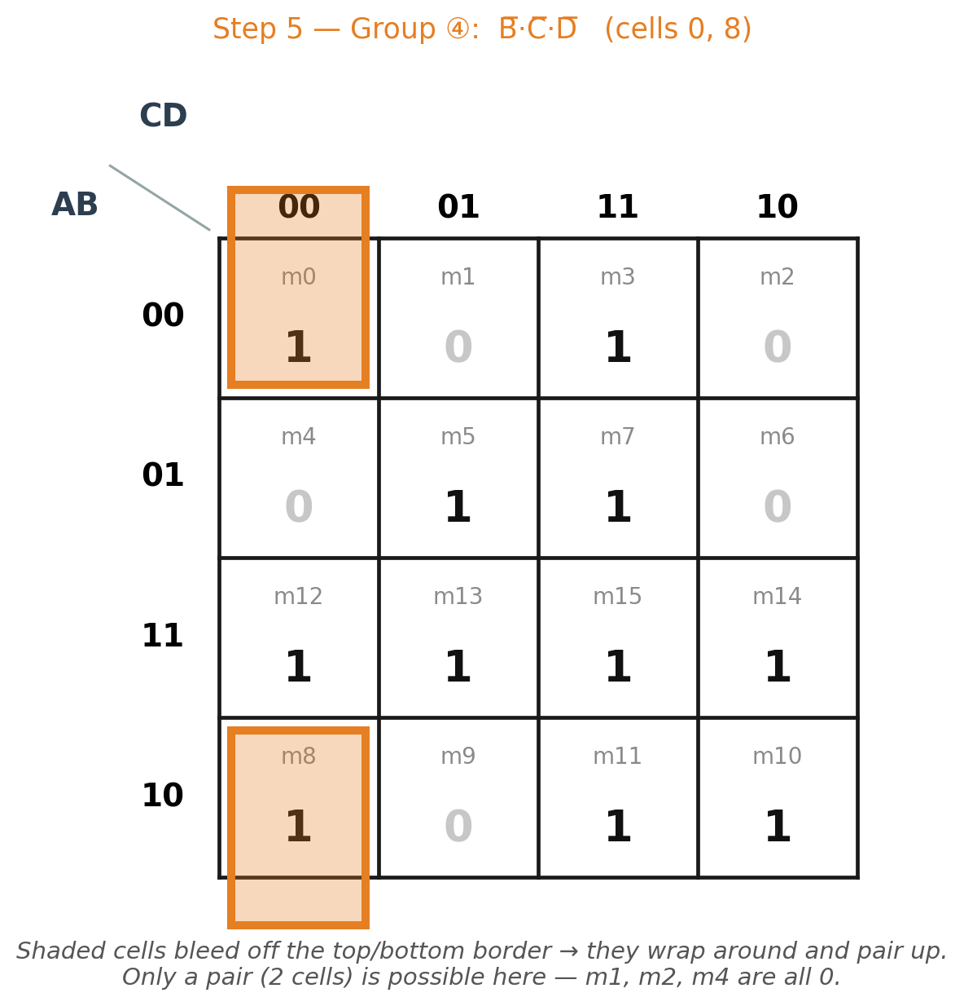

A.7 — Why Exactly These Four Groups
Cell 0 is adjacent to only one other 1 (cell 8), so Group ④ is forced — it is the only group that can ever cover cell 0. Cell 3's only maximal group is the CD column, so Group ③ is forced the same way, and cell 5's only maximal group is the BD block, so Group ② is forced too. Once those three groups are placed, cells 10, 12 and 14 are still uncovered, and Group ① (A · D′) is the only single group that covers all three of them at once — so it completes the cover using the fewest possible terms.

A.8 — Combine the Groups & Final Answer
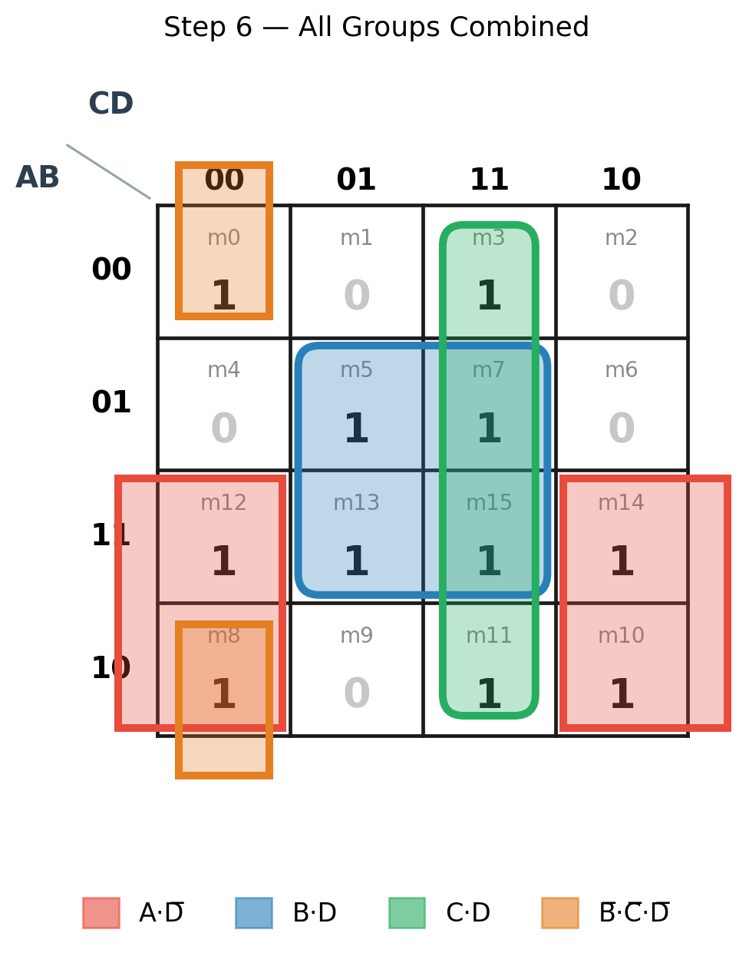
FINAL SIMPLIFIED SOP EXPRESSION
F(A, B, C, D) = A D′ + B D + C D + B′ C′ D′
Quick check: substituting all 16 combinations of A, B, C and D into this expression reproduces exactly the eleven 1s and five 0s given in the problem, confirming the simplification is correct.

PART B — K-Map Grouping Strategy: Complete Study Guide
A general reference on reading and grouping any 4-variable K-map — useful revision material beyond this specific question.

B.1 — What a K-Map Is For
A Karnaugh map is a truth table rearranged into a grid so that physically neighbouring cells always differ in exactly one variable. That single property is what turns Boolean simplification into a pattern-spotting exercise: a valid loop drawn around neighbouring 1s is always a legal simplification, because the variables that change across the loop are precisely the ones that cancel out of the term.

B.2 — The Gray-Code Adjacency Rule
Row and column headers are written 00, 01, 11, 10 — not the natural binary count order 00, 01, 10, 11 — because consecutive Gray-code values differ in only one bit. This is also why the map wraps: the last header (10) and the first header (00) differ in only one bit too, so the last row/column is adjacent to the first. The chart below shows exactly which minterm number sits in every cell of a 4-variable map — it's worth memorising.
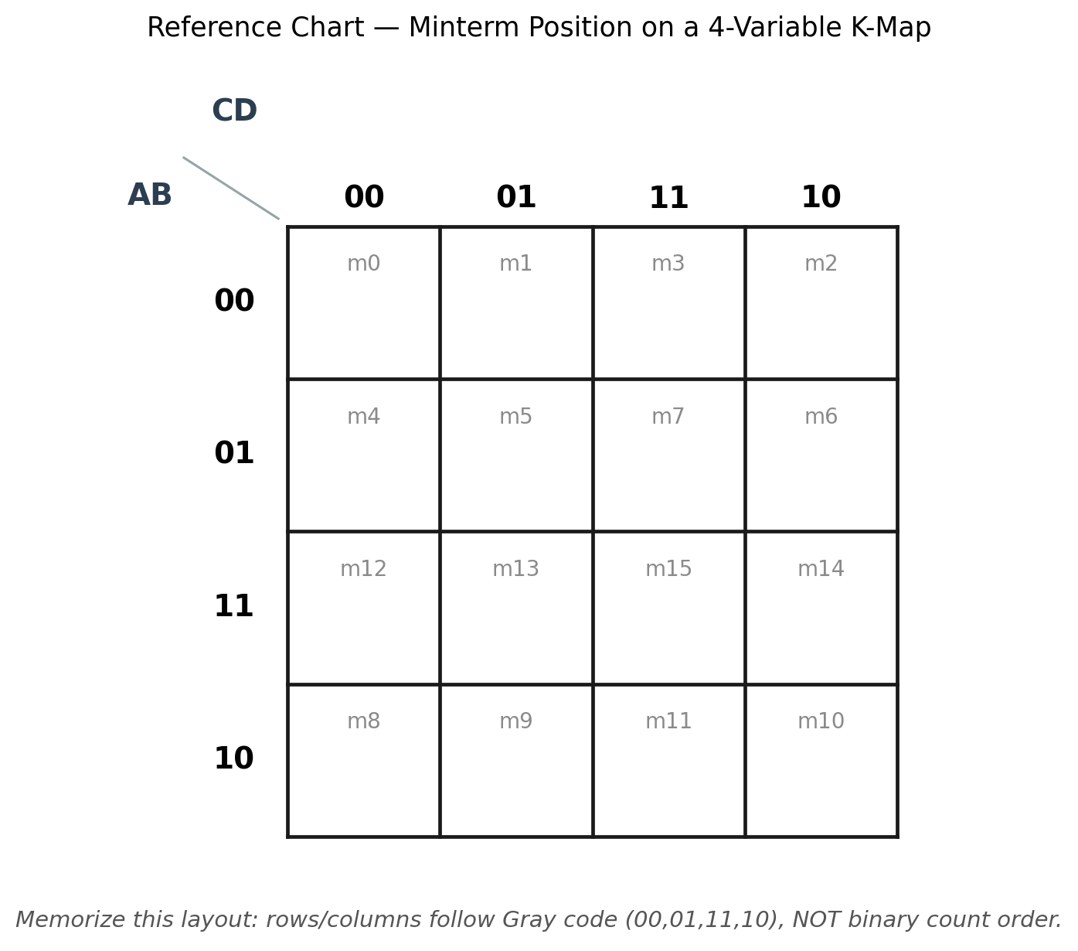

B.3 — The Golden Rules of Grouping
- Group size must be a power of 2 — 1, 2, 4, 8 or 16 cells. No other size is a legal group.
- A group must form a rectangle: a straight line, a square or rectangular block, or a shape that wraps around an edge. Diagonal or L-shaped groupings are never valid.
- The map wraps on every side: the left edge touches the right edge, the top edge touches the bottom edge, and — as a consequence — all four corners of the map touch each other too.
- Groups are allowed to overlap. The same 1 can belong to more than one group if that lets other cells form bigger groups of their own.
- Always make each group as large as possible. Doubling a group's size removes exactly one more variable from its term.
- Every 1 (and every don't-care you choose to use) must end up inside at least one group — none can be left ungrouped.
- Don't keep a group whose 1s are already fully covered by other chosen groups — it only adds an unnecessary term.

B.4 — Grouping Shapes Gallery
The four shapes below are every valid grouping shape you will meet in a 4-variable K-map.
Pair (2 cells) — eliminates 1 variable
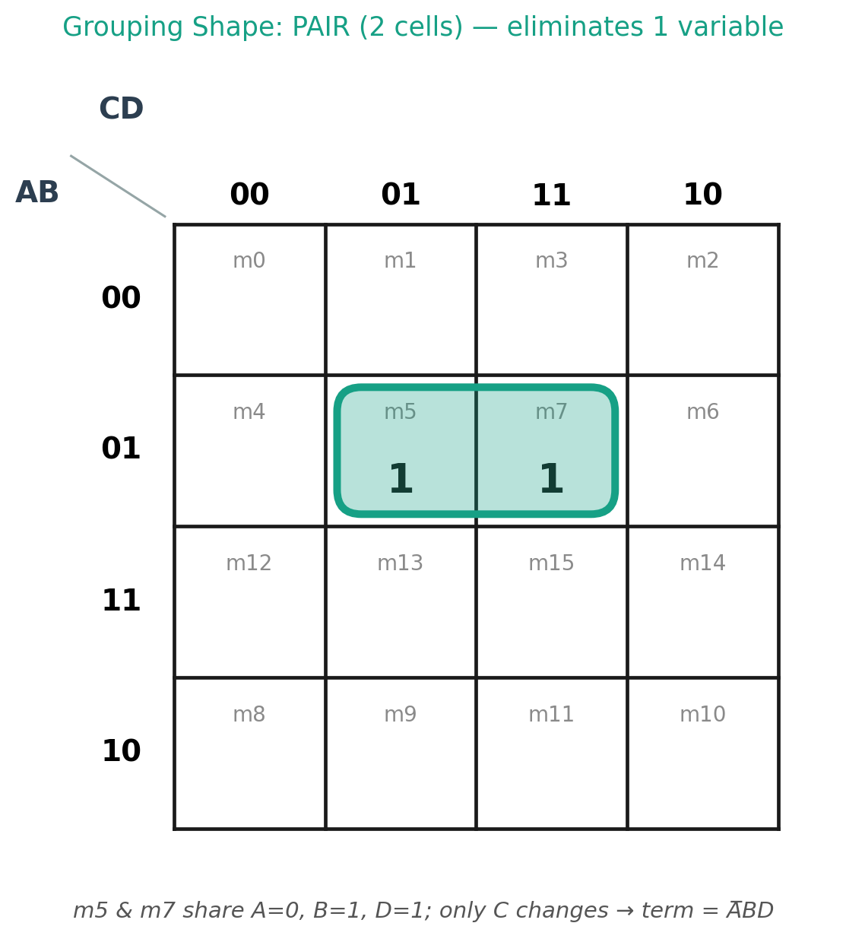
Quad — 2×2 block (4 cells) — eliminates 2 variables
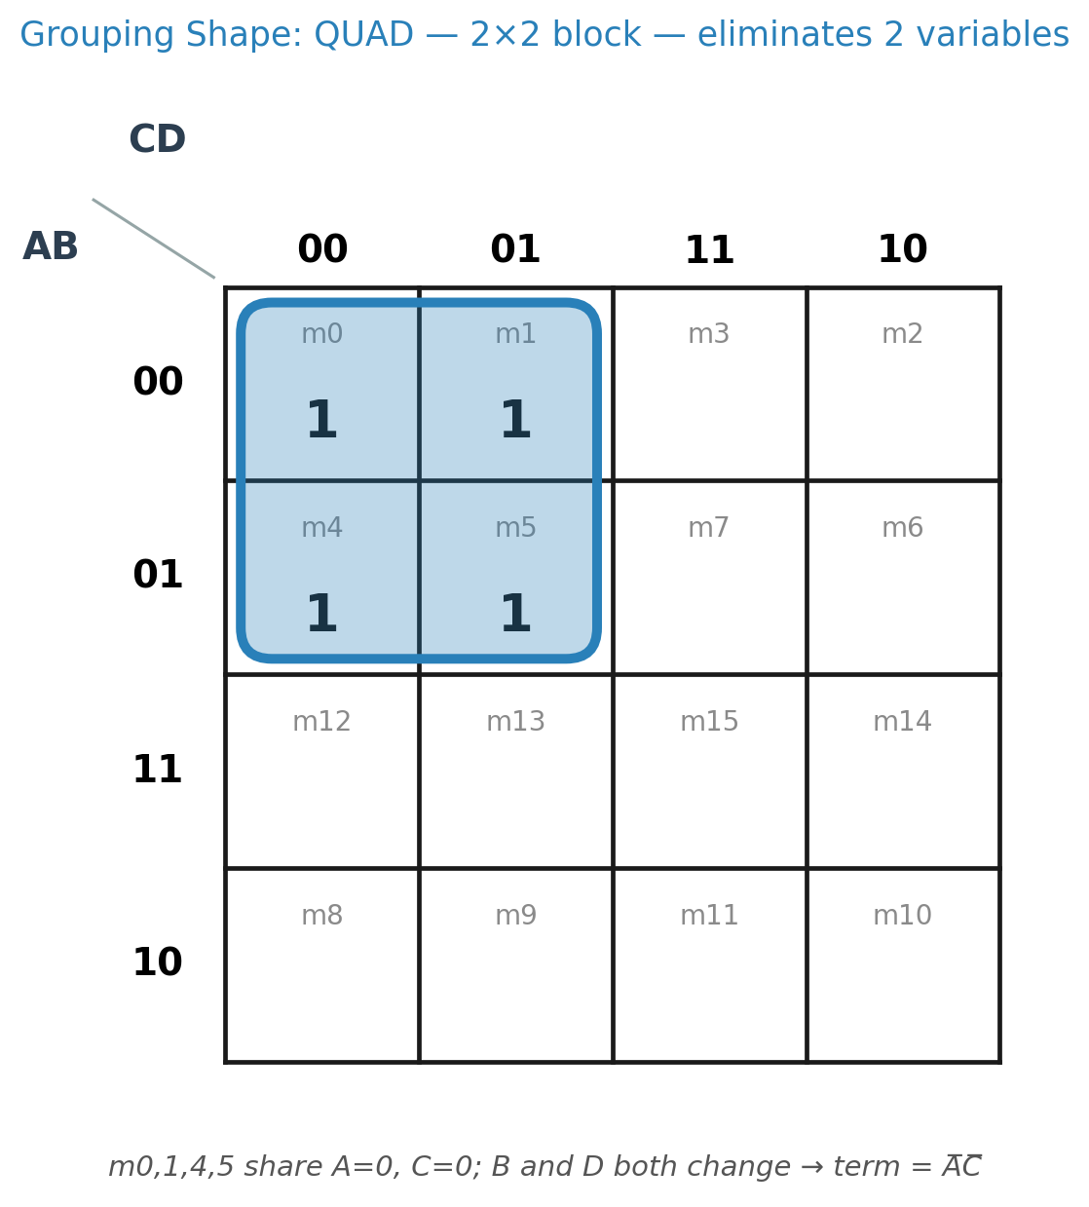
Quad — wraparound corners (4 cells) — eliminates 2 variables
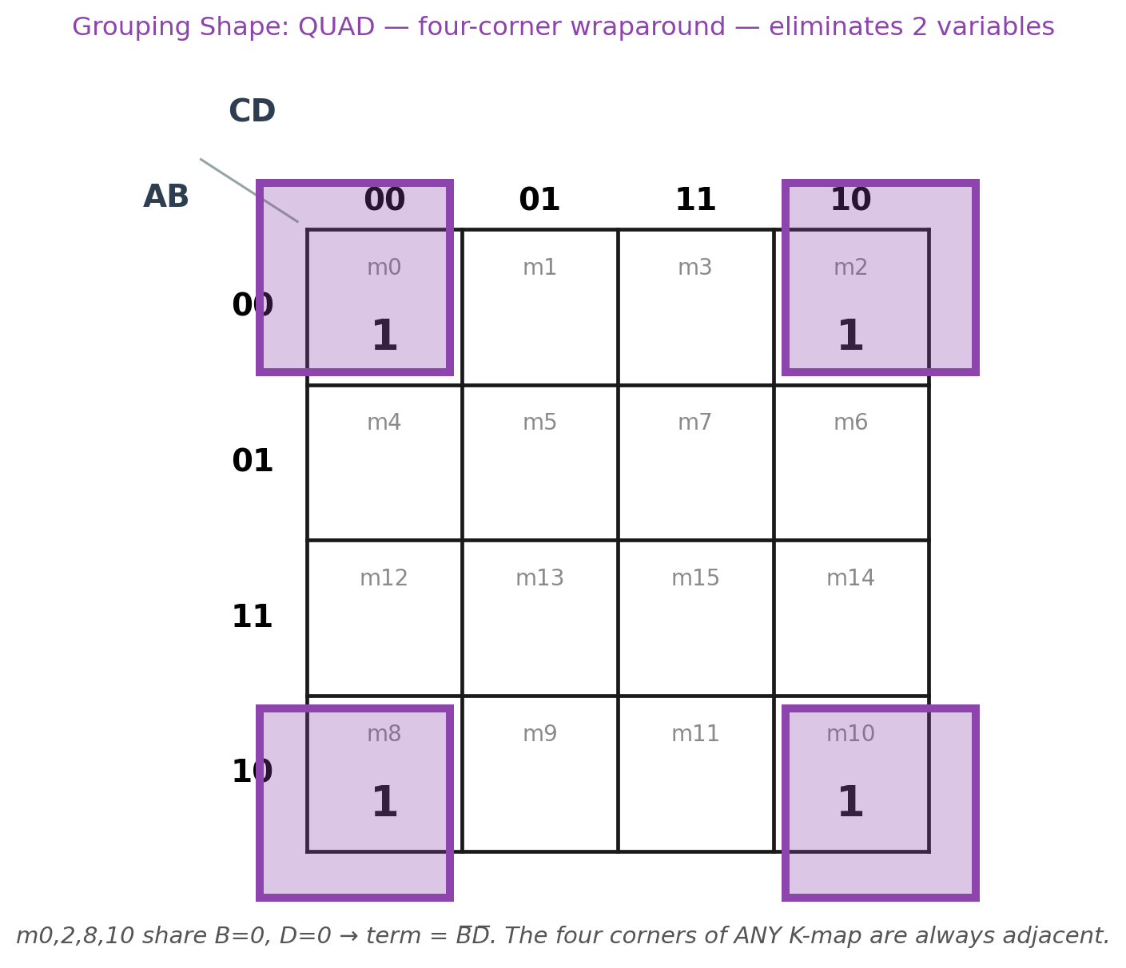
Octet (8 cells) — eliminates 3 variables
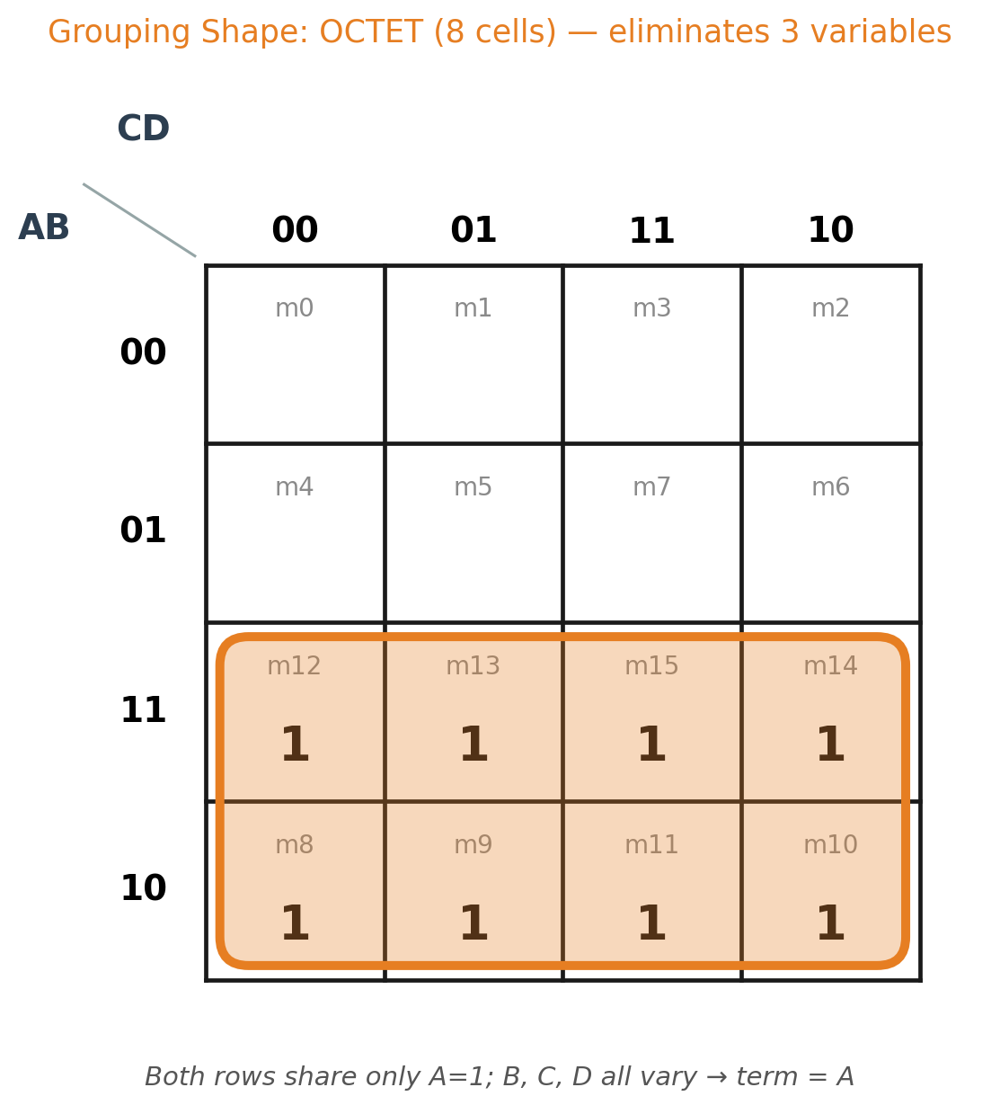

B.5 — Invalid Groupings: The Full Picture
A grouping attempt can fail for more than one reason. The five cases below are every way a loop can be illegal — knowing all five is just as important for exam marks as knowing the valid shapes, since markers deduct for any of them.
① Diagonal cells are never adjacent
Cells that only touch at a corner differ in two bits at once, so they can never be looped together — no matter how tempting the diagonal pattern looks.
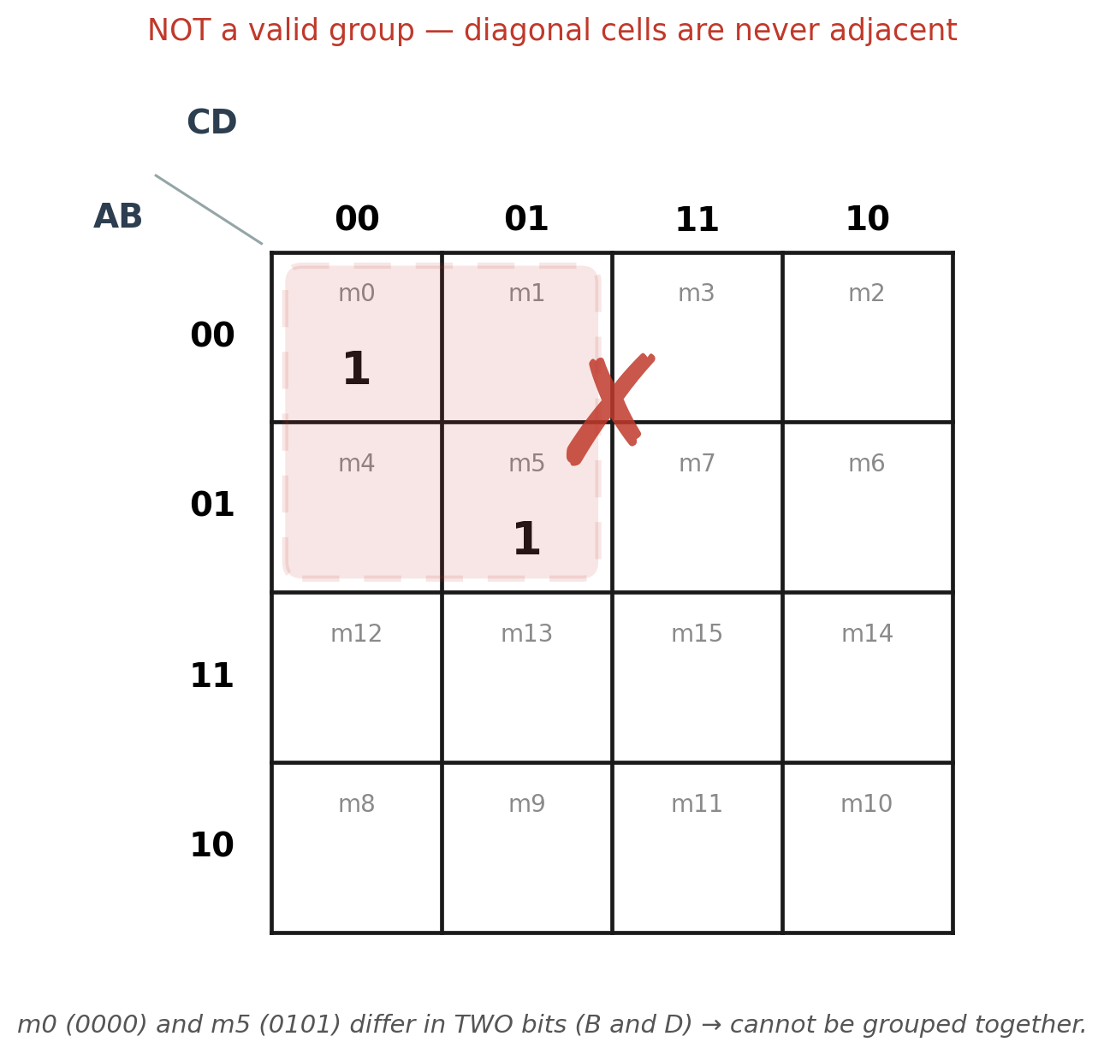
② Group size must be a power of 2
Only 1, 2, 4, 8 or 16 cells are legal. A group of 3, 5, 6 or 7 is illegal even if the cells happen to sit in a neat-looking row.
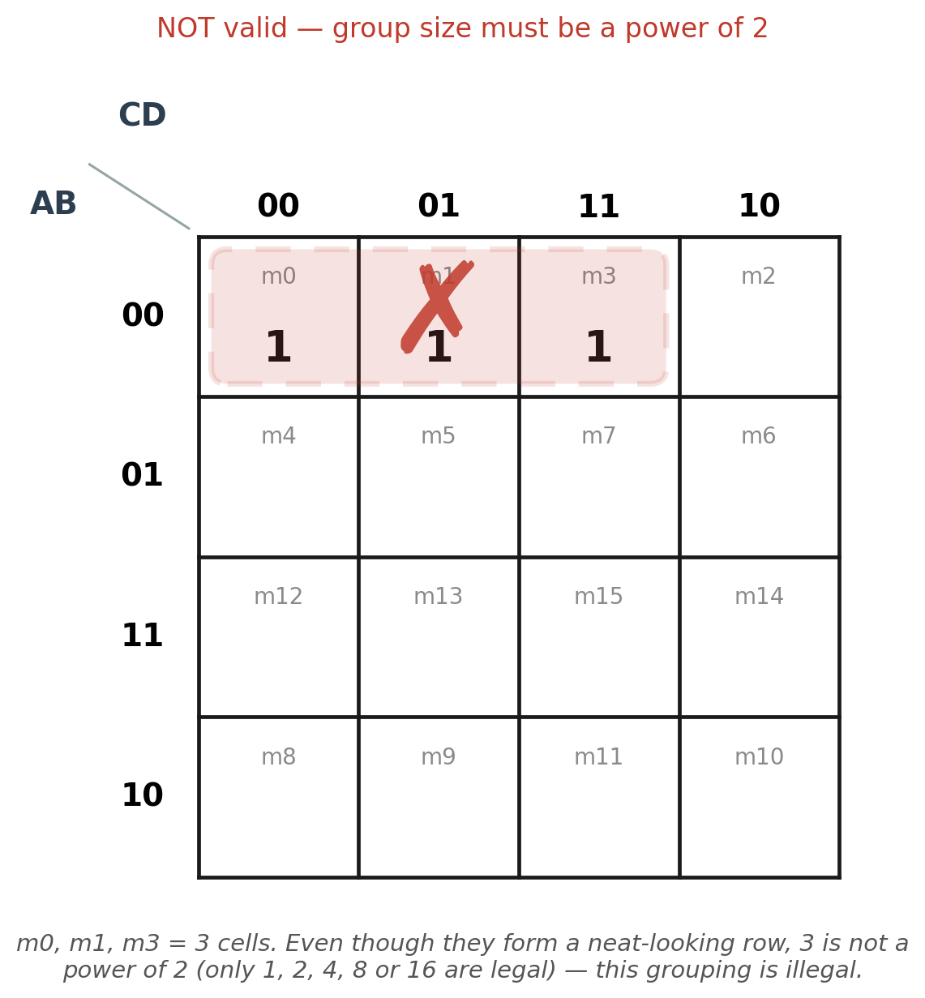
③ The shape must be a rectangle
A legal group is always a straight line, a square/rectangular block, or a wraparound version of one of those. An L, T, S or Z shaped cluster of cells is illegal even when the count is a valid power of 2.
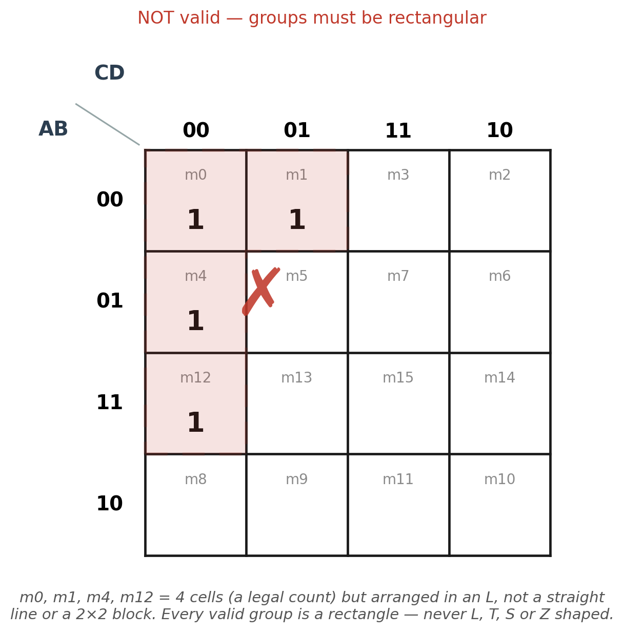
④ Every cell in the group must be 1
A loop can only enclose 1s (and any don't-cares you've chosen to treat as 1). Pulling in even one confirmed 0 makes the whole group invalid, regardless of how the shape looks.
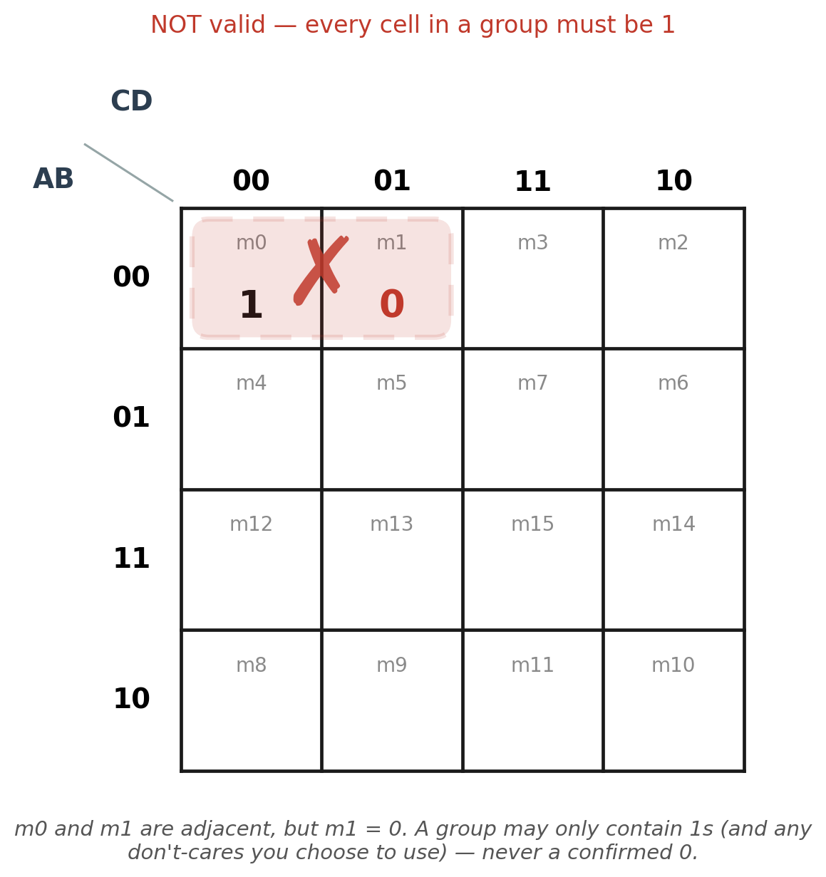
⑤ Skipping a cell is not the same as wraparound
Only the true edge-to-edge wrap counts as adjacency (first row/column with the last one). Jumping over a row or column in the middle of the map — without using that specific wraparound — is not a legal adjacency.
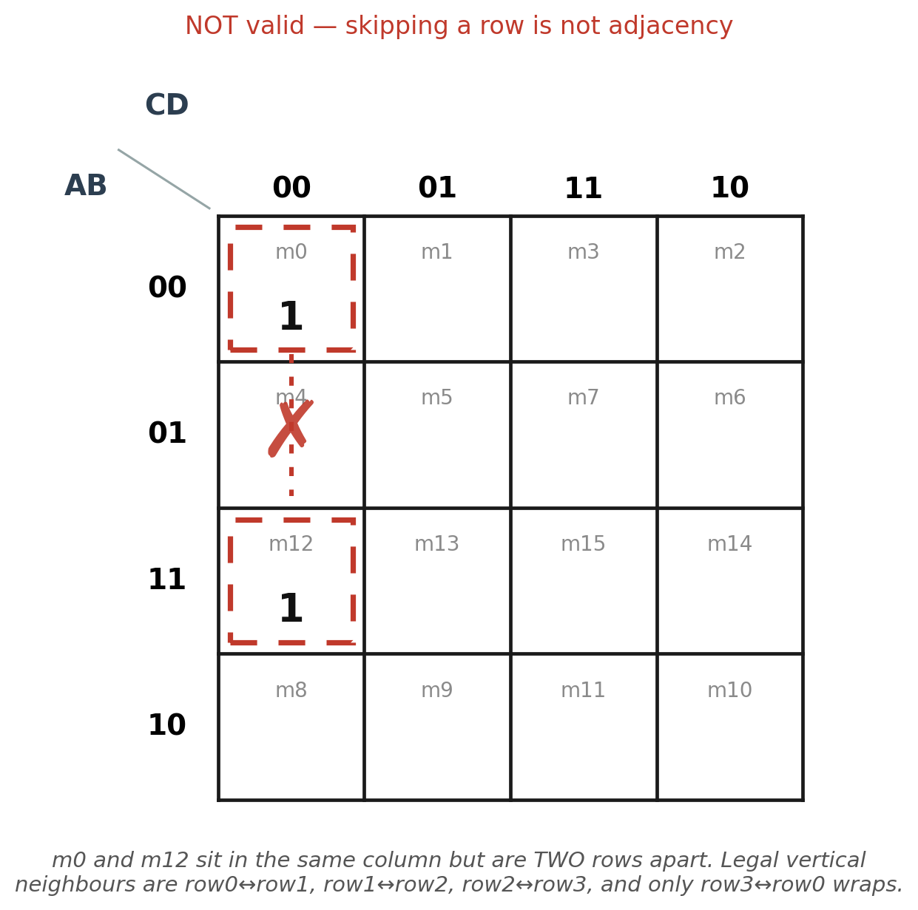

B.6 — Prime Implicants & Essential Prime Implicants
A prime implicant is a group that cannot be grown any larger — merging it with any neighbouring group of the same size would pull in at least one 0. An essential prime implicant is a prime implicant that is the only group able to cover some particular 1; that 1 forces its group into the final answer no matter what else is chosen.
In the worked example in Part A: cell 0 forced B′C′D′, cell 3 forced C·D, and cell 5 forced B·D — all three are essential prime implicants. A·D′ is a prime implicant too, and although no single cell forces it on its own, it was the only group able to finish covering cells 10, 12 and 14 together, so it remained the right choice for a minimal answer.

B.7 — Step-by-Step Algorithm for Any K-Map Question
- Draw the 4×4 grid and label the rows and columns in Gray-code order (00, 01, 11, 10).
- Fill in every cell with its minterm's value — 1, 0, or X for a don't-care.
- Start with any 1 that has the fewest 1-valued neighbours — it usually has only one legal grouping, making it essential.
- For every 1, try to place it in the largest group possible: test 8 cells first, then 4, then 2, falling back to a lone cell only if nothing bigger works. Always check the wraparound before settling for a smaller group.
- Mark every essential prime implicant — a group that is the only one covering some particular 1 — these must all be included.
- If any 1s are still uncovered after the essential groups, add the fewest additional groups needed to cover them.
- Write one product term per chosen group, keeping only the variables that stay constant across every cell in that group.
- OR all the product terms together — that sum is the final minimal SOP expression.

B.8 — Common Mistakes to Avoid
Mistake | Why It's Wrong
Grouping diagonal cells | Diagonal cells differ in 2 or more bits, so they are never adjacent.
Forgetting the wraparound | The map's edges connect to each other; missing this hides valid larger groups and gives a non-minimal answer.
Using a group size that isn't a power of 2 | Sizes such as 3 or 6 cells are not legal Boolean groupings.
Picking a smaller group when a bigger one exists | A smaller group keeps extra literals that a bigger valid group would have removed.
Leaving a 1 uncovered | The simplified expression will no longer equal the original function.
Adding a redundant group | If every 1 in that group is already covered elsewhere, the term adds length without adding correctness.

B.9 — Quick Reference: Group Size vs. Literals
Group Size | Variables Eliminated | Literals Remaining
1 cell | 0 | 4
2 cells (pair) | 1 | 3
4 cells (quad) | 2 | 2
8 cells (octet) | 3 | 1
16 cells (whole map) | 4 | 0 (constant 1)

